**CEG4913 Weekly Progress Report**

Week #: 3

SCRUM/Sprint No. 11

Group Number: 3

Date: September 25th, 2025

One line summary of progress:

Started development on database and CI pipeline

# Work Completed

## Hardware:

* Ordered new parts (Camera, pressure sensors, power supply)

## Software:

* Added toast notification for driver removal

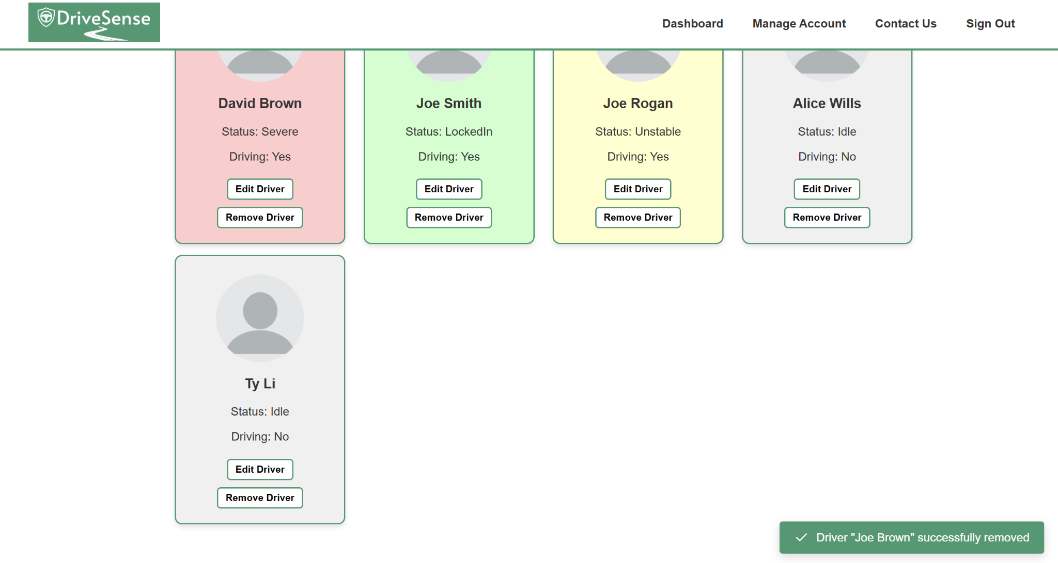

* Added the logout button and began development of screen UI using React JS

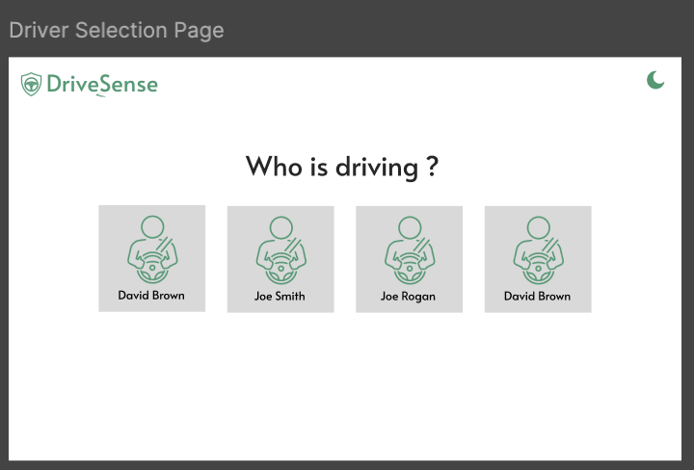

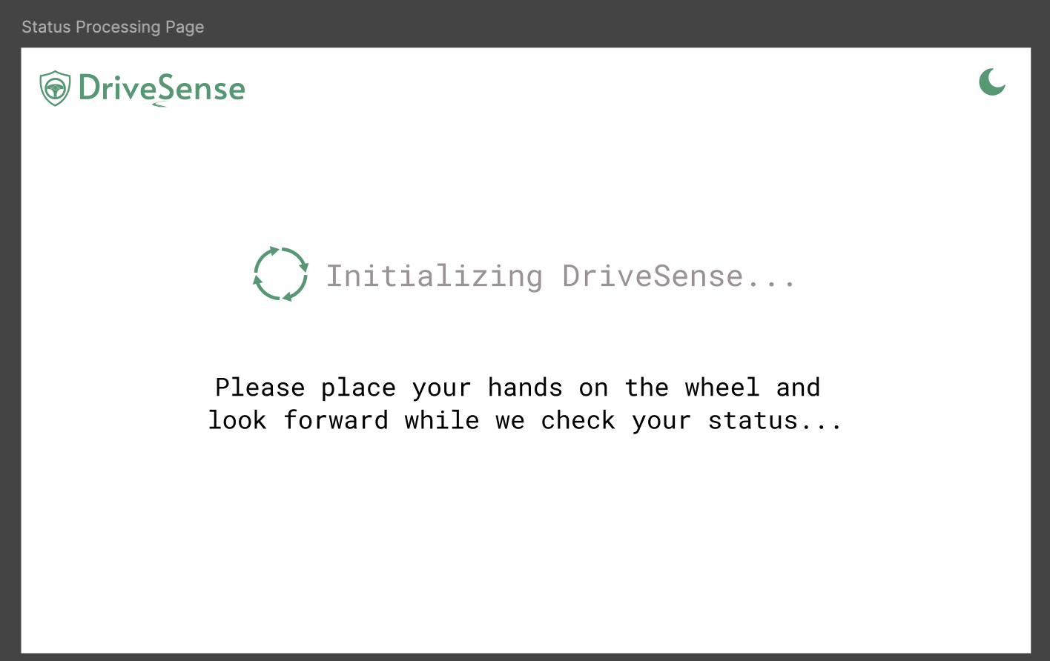

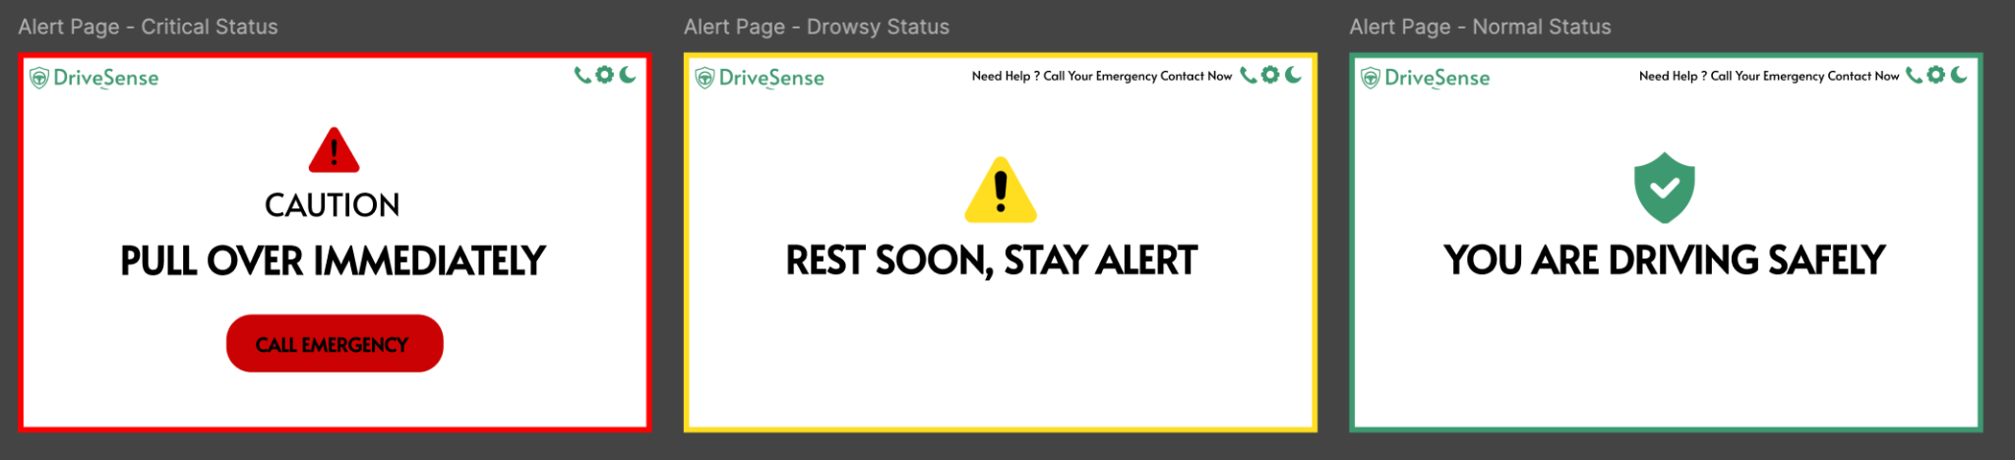

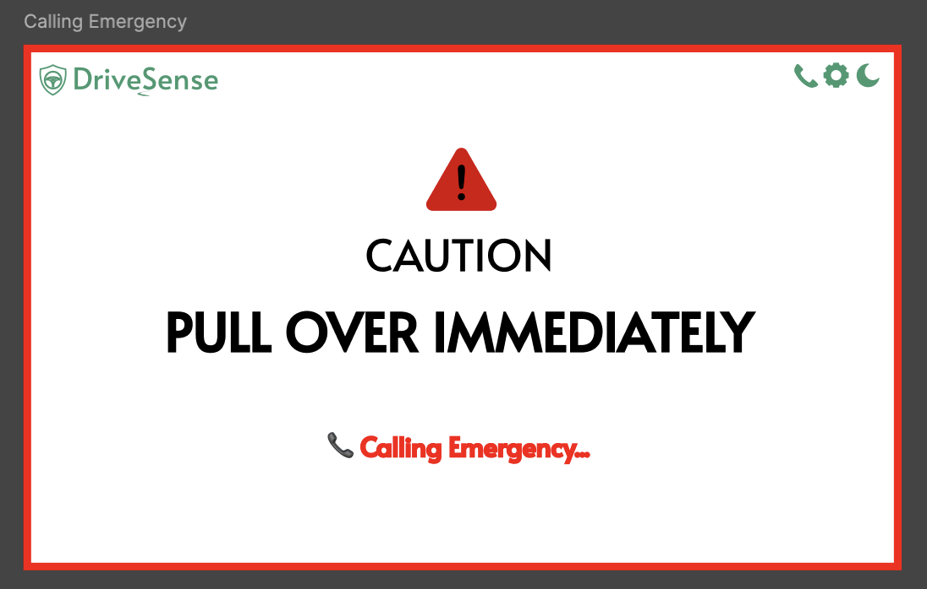

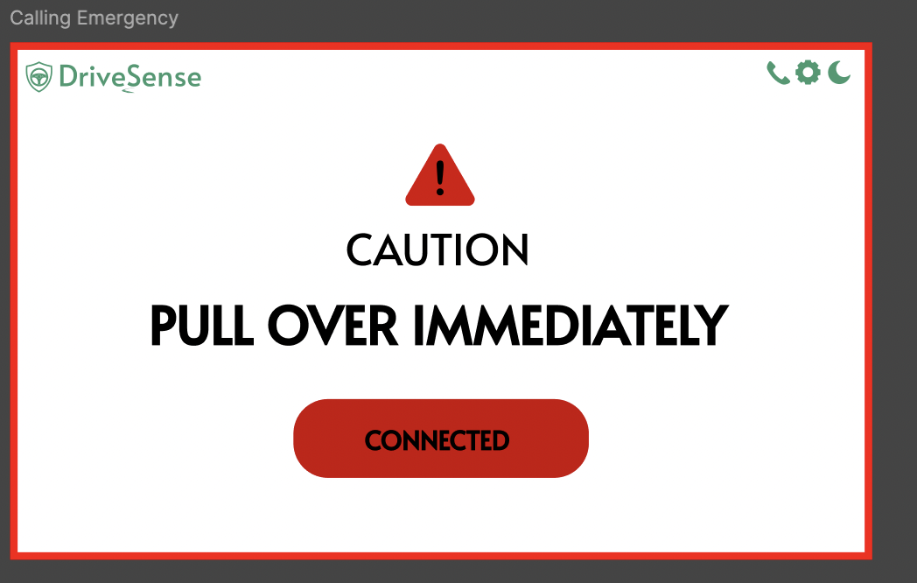

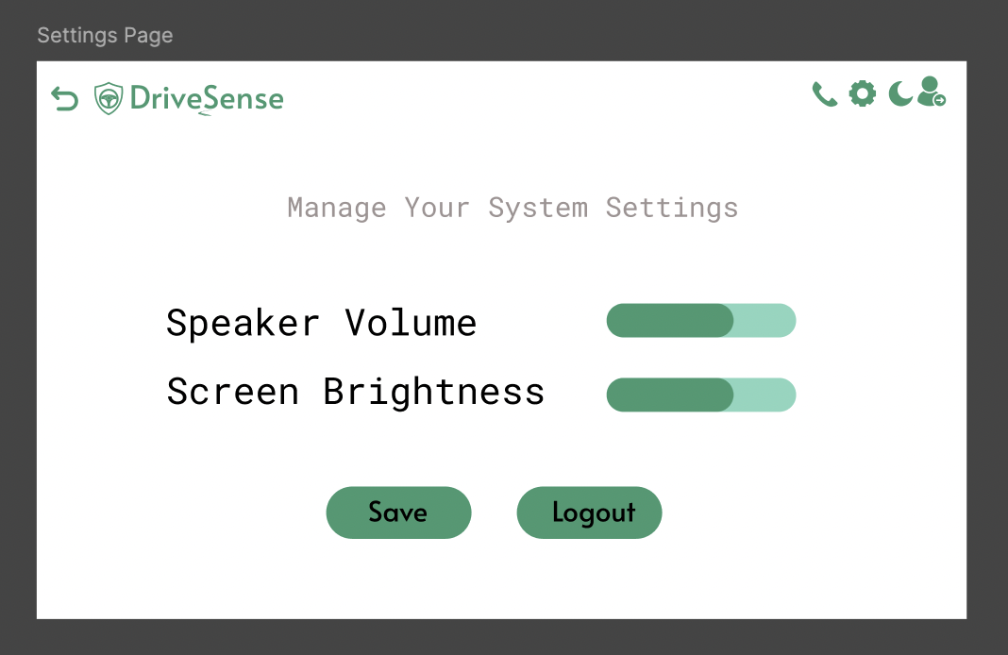

* Setup database and created database tables for the data will be using for website
* Begun development on REST API’s
* Dockerized jetson nano environment to allow dev and testing remotely
* Created another docker container to allow the database to run at all times

## 

## Team Member Contributions:

Aaditya Shah:

* Sourced new hardware

Abdullah Ramadan:

* CI Pipeline Structure Implemented

Keith Tran:

* Set up Twilo account
* Coded Twilio implementation for screen device

Kevin Dang:

* Added toast notification for driver removal
* Began working on REST API’s for database

Hajer Fguir:

* Finalized the UI Screen Mockup
* Started the development of the car screen
* Prepared a detailed list of APIs required for the UI screen

Saurav Guduru:

* Setup database tables on firebase
* Dockerized a jetson nano environment
* Created a docker container to host the firebase database

## Issues and Resolutions:

Issue: None

Status: N/A

Resolution: N/A

# Plans for next week:

## Hardware Goals:

* Test new camera, pressure sensors and power supply
* Perform integration test with all HW
* Get measurements for new HW

## Software Goals:

* Complete all API’s related to sensor and UI data for database
* Create a main thread to survey all modularized drivers for HW
* Write unit tests
* Start the development of the new UI car Screen using React JS
* Prepare the list of APIs needed for the UI screen

## Management Board Screenshots:

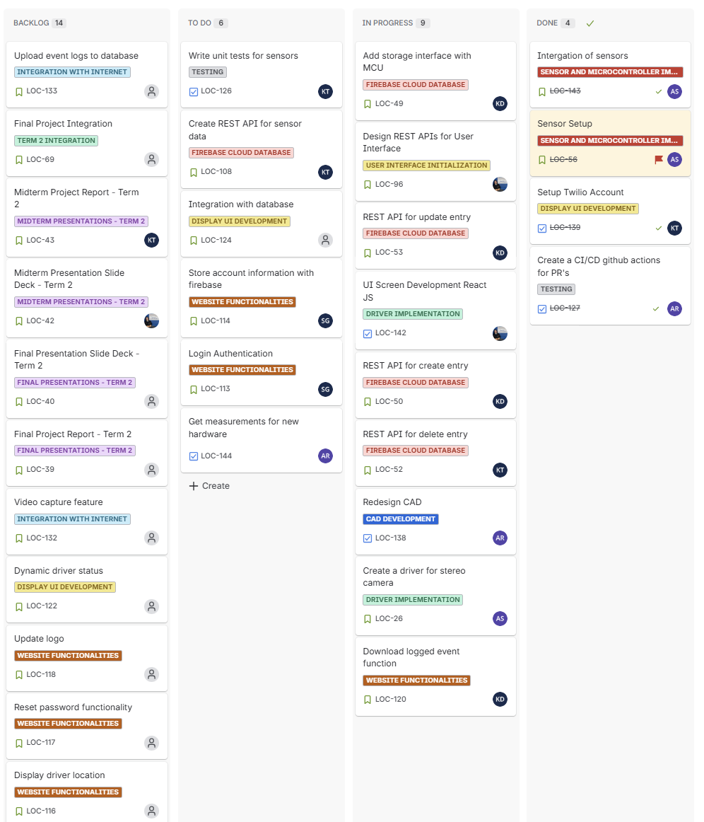

Figure 1 - General Management Board

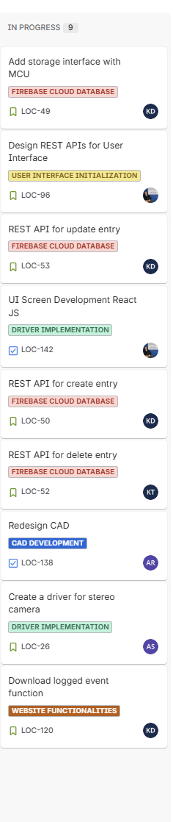

Figure 2 - This Week’s Sprint

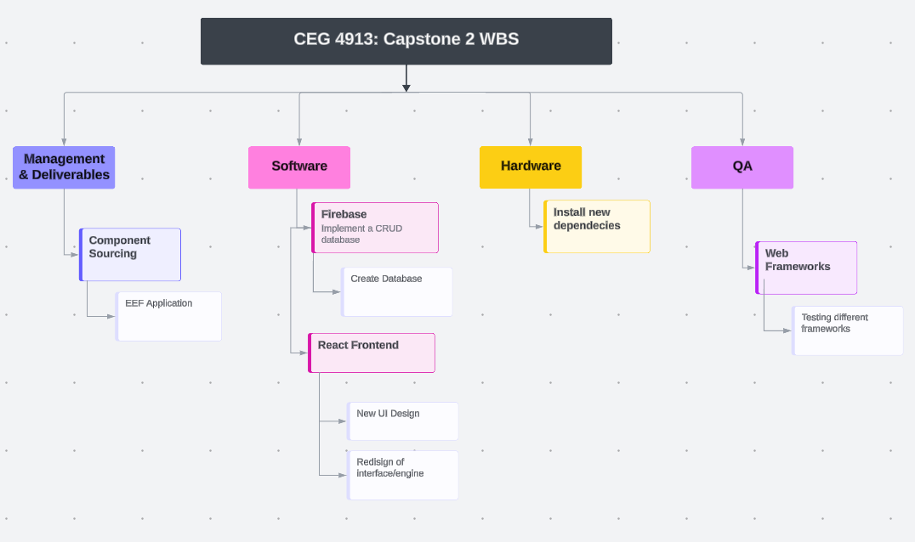

Figure 3 - WBS

## Additional Notes: